Lab3: Debug service use the repo nginx-svc

Create Argo Application

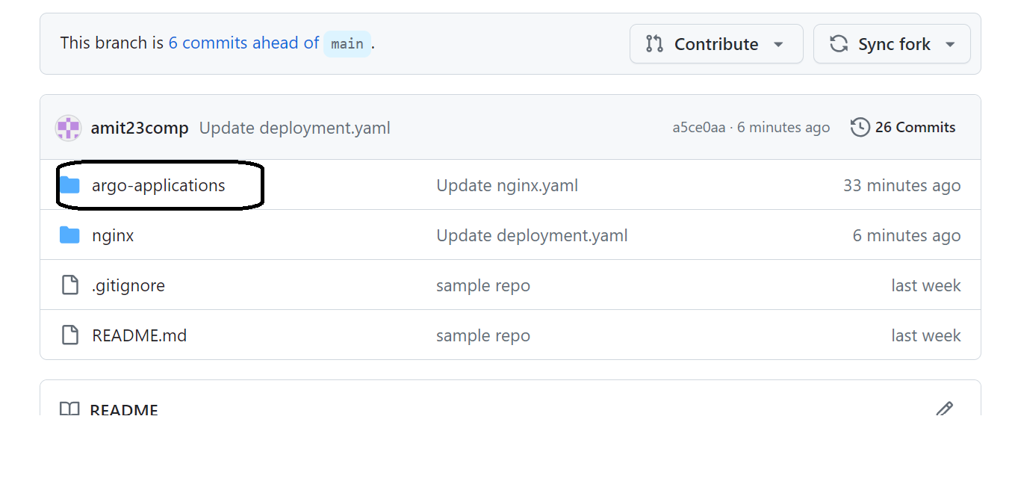

1. Open nginx.yaml :

* modify the name under metadata
* Modify .spec.source.targetRevision, put your branch

apiVersion: argoproj.io/v1alpha1

kind: Application

metadata:

name: amit-nginx

namespace: argocd

spec:

destination:

name: arn:aws:eks:ap-south-1:130705418859:cluster/stage-devseccops-eks-cluster

namespace: stage-nginx-namespace

project: stage-devseccops

source:

path: nginx-svc

repoURL: git@github.com:amitopenwriteup/nginx-argoproj.git

targetRevision: amit

syncPolicy:

automated: {}

1. Login to argo UI

<https://argocd.devseccops.ai/>

username: admin

Password: ask the trainer

1. Click on new app

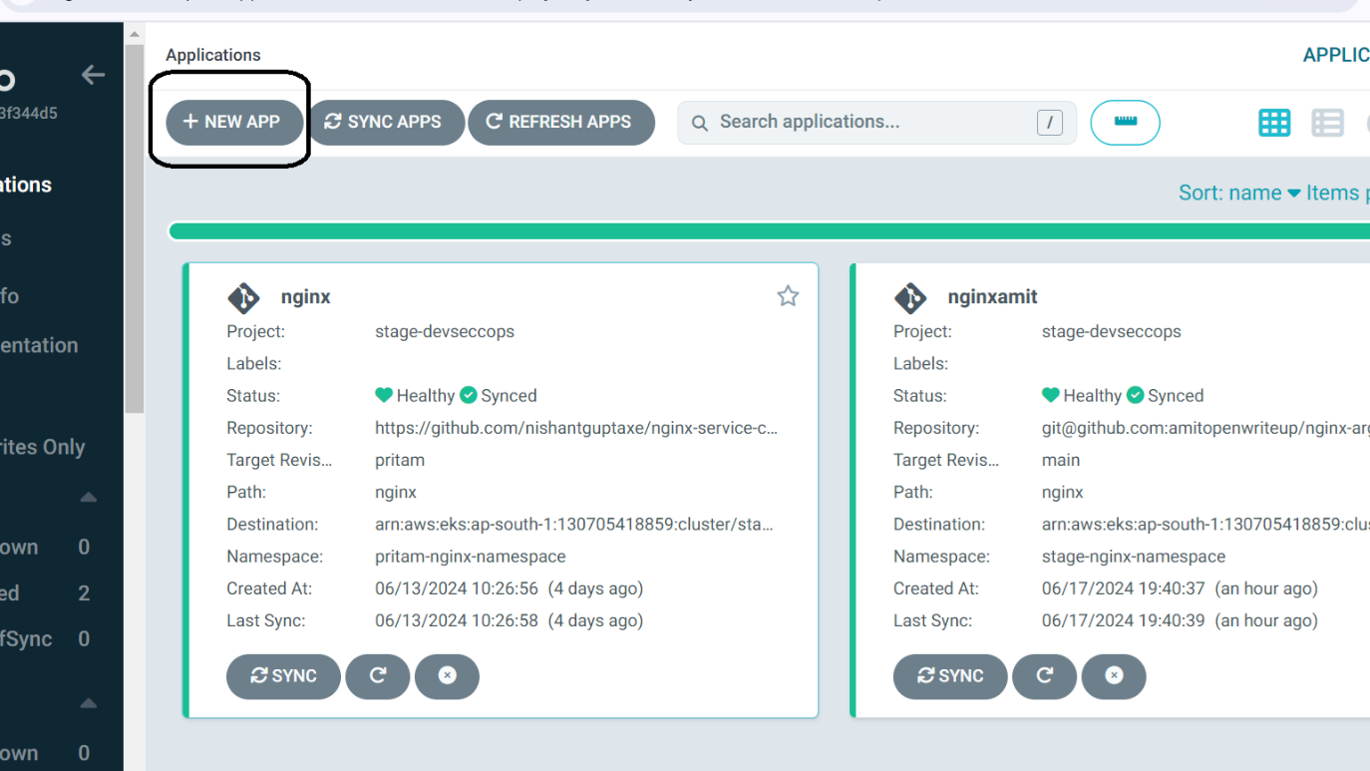

1. Click on Edit as yaml

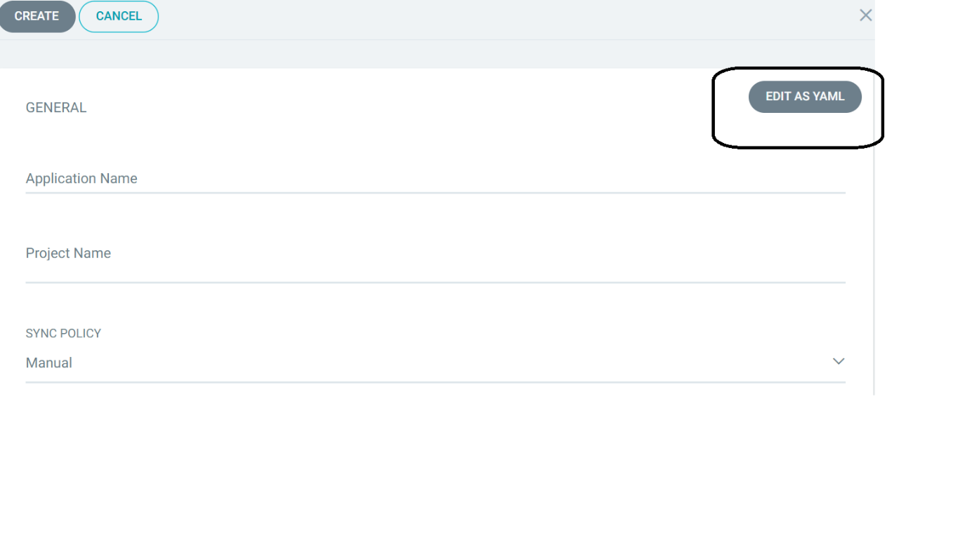

1. Copy and paste the nginx.yaml file which you have modified in step 1 of this doc

apiVersion: argoproj.io/v1alpha1

kind: Application

metadata:

  name: amit-nginx

  namespace: argocd

spec:

  destination:

    name: arn:aws:eks:ap-south-1:130705418859:cluster/stage-devseccops-eks-cluster

    namespace: stage-nginx-namespace

  project: stage-devseccops

  source:

    path: nginx

    repoURL: git@github.com:amitopenwriteup/nginx-argoproj.git

    targetRevision: amit

  syncPolicy:

    automated: {}

1. Save and Create

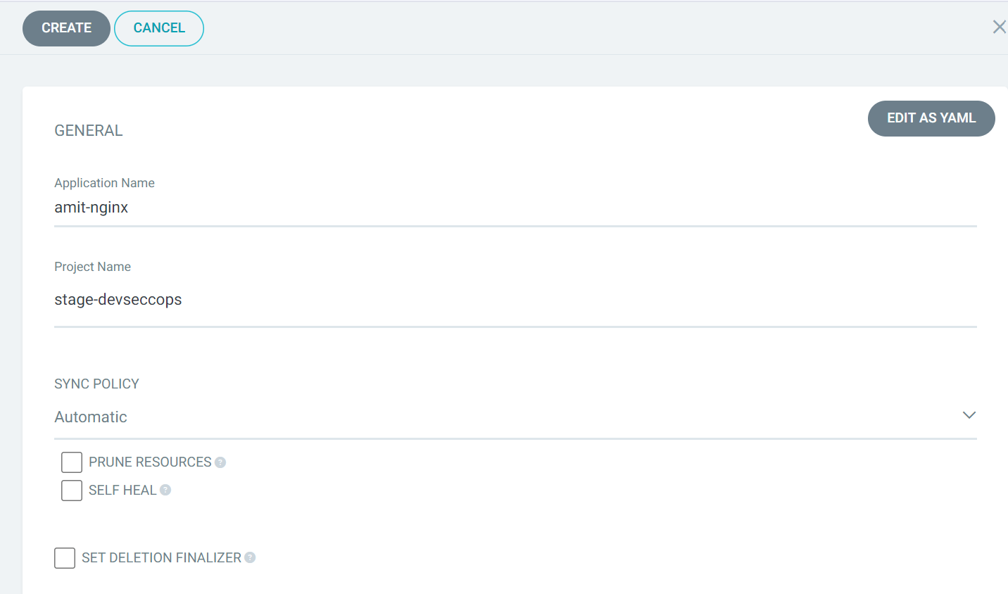

Check the health

**Assignment:**

**Delete it, and recreate again without yaml**

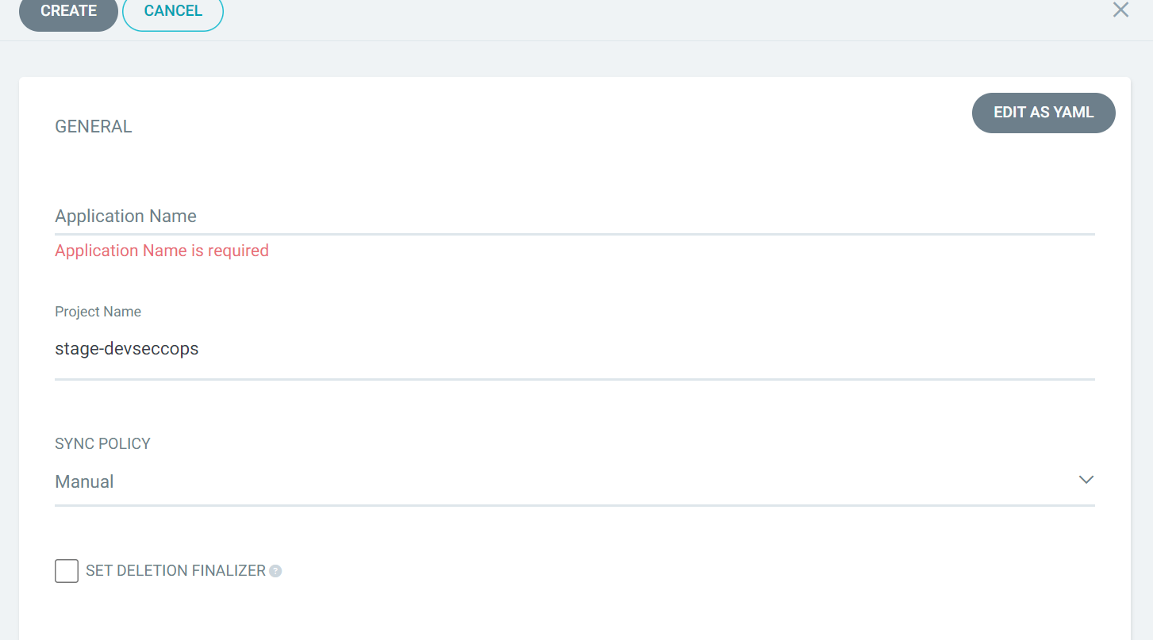

This time use the source git url: git@github.com:amitopenwriteup/nginx-argoproj.git

Project name: stage-devseccops

Destination : <https://6C6D06137920FB7B2ADE9485E8FF6ABF.gr7.ap-south-1.eks.amazonaws.com>

Revision: Branch name which you created

Path: nginx

**Note: Check the namespace option in the UI, in case its failing**